Hall Ticket | 0425046013
Name of the Student | BURRI NIKSHITHA
Learning Track | DATA ANALYTICS WITH TABLEAU

Assignment
Area Chart:
- We have to drag the Order Data into the columns.
- Then right click on Year (Order Date) in the columns.
- Then select the Month.
- Drag Quantity to the Rows.
- Then we have to drag Ship mode to colour on the Marks card.
- On the Marks Card, click on drop down menu.
- Select the Area Chart in the Chart type.

OUTPUT:
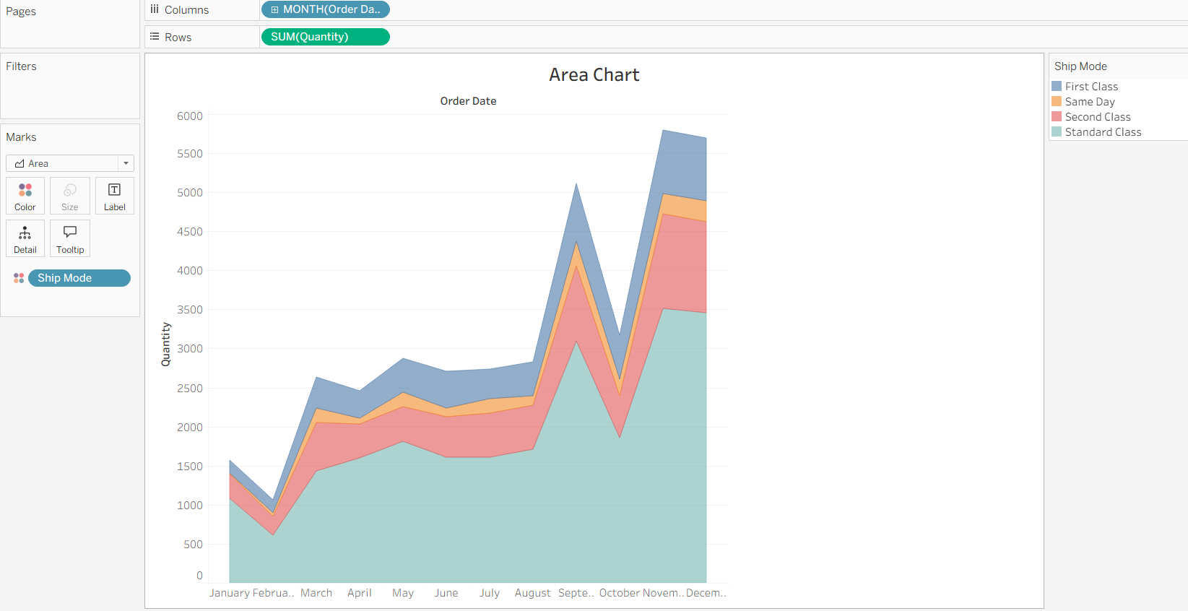

Bar Chart:
- We have to drag Sales into the Rows.
- On the Marks Card, click the drop-down menu.
- Select the Bar chart in the Chart type.
- Drag Region to the Rows in the left side of the Sales.
- Again, drag Region to the Filters.
- In Filter Dialog box, keep only west remaining all uncheck.
- Click Ok.

OUTPUT:

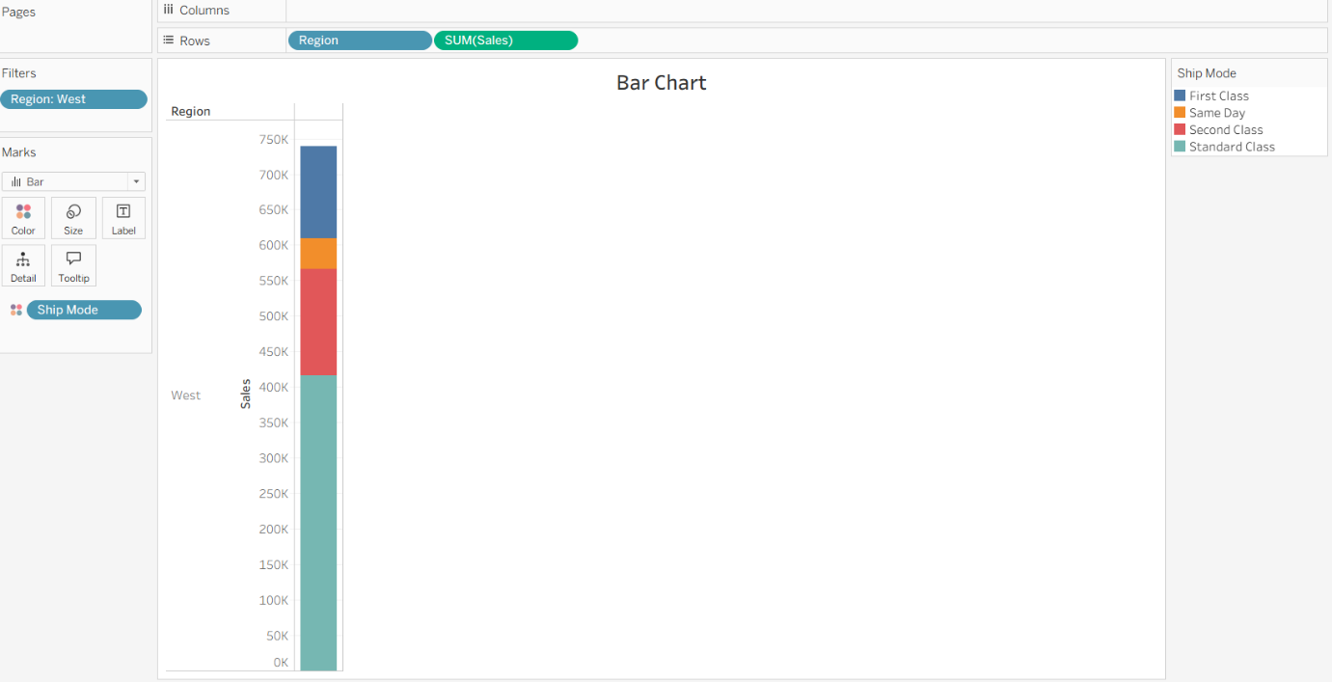

Box Plot:
- We have to drag Segment into the columns.
- We have to drag Discount into the Rows.
- Then click Discount on Rows.
- Move your mouse pointer and keep it on the Measure(Sum) field.
- Then change the aggregation to Average.
- Drag Region to columns.
- It will be placed on right side of the Segment.
- Click on Show me in toolbar.
- Select Box and Whisker Plot.
- Move Region next to Segment on the column area.
- Go to Analysis menu.
- Then Uncheck the Aggregate measures.
- Click Swap Rows and Cloumns button.

OUTPUT:
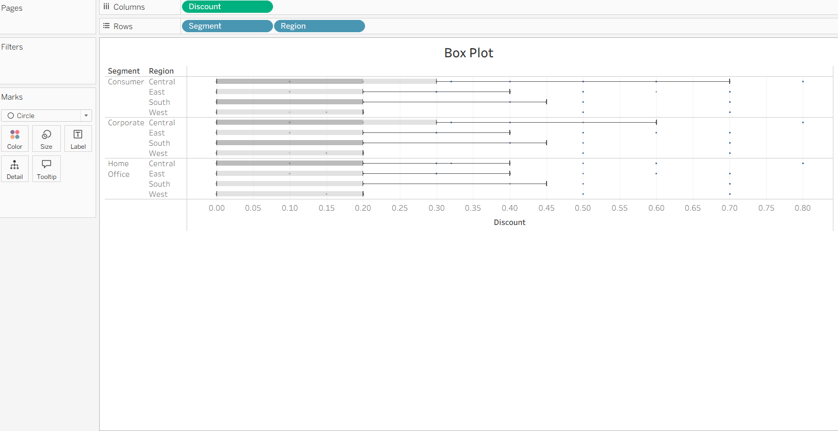

Gantt Chart:
- We have to drag Order Date into the colunms.
- Click drop down arrow on Year (Order Date) in columns.
- Then select Week Number.
- Drag Sub Category into the Rows.
- Drag Ship mode to rows in the right side of the Sub category.
- In Marks card, click on drop down arrow.
- Then select Gantt Bar in the Chart type.
- Click Analysis Menu.
- Select Create Calculate Field.
- Type the Name – OrderUntilShip.
- Formula – DATTEDIFF(‘day’,[Order Date],[Ship Date])
- Then click Ok.
- Drag OderUntilShip to Size in the Marks cards.
- Right Click on Sum(OderUntilShip) on the Marks Card.
- Click on Measures.
- Click on Average.
- Drag Ship Mode to colour in the Marks Card.

OUTPUT:
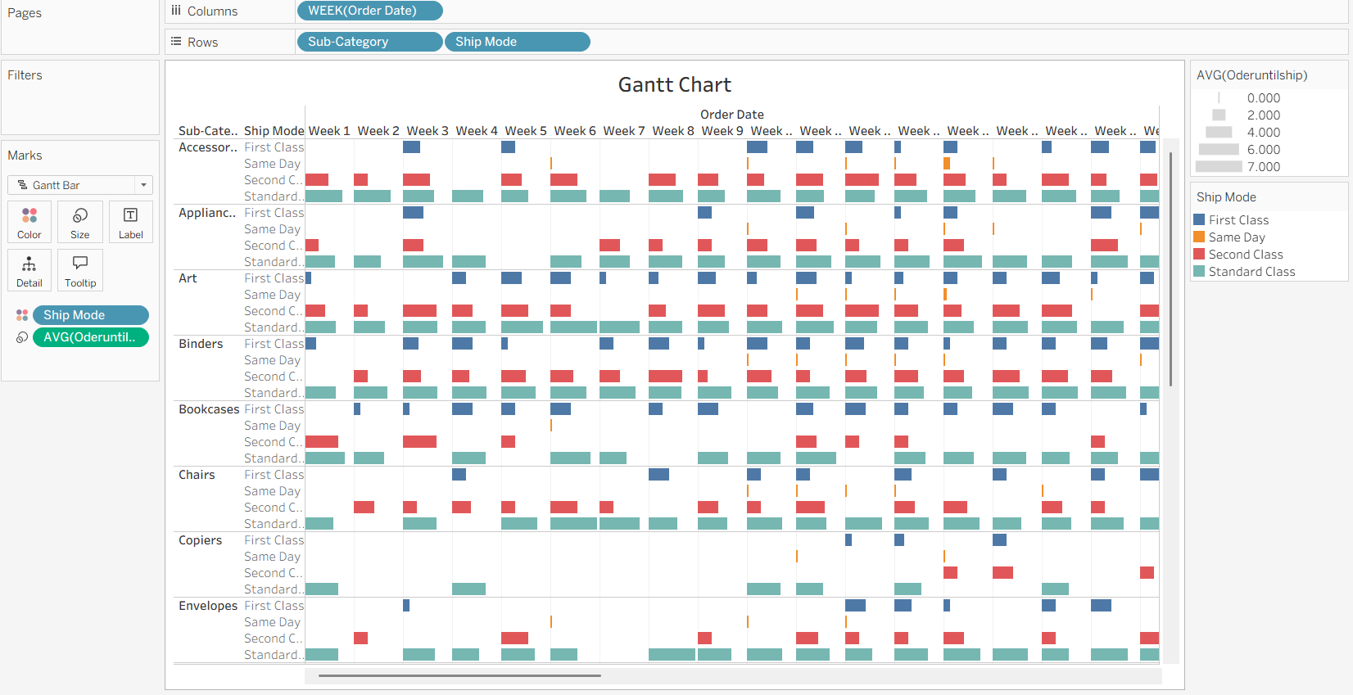

Heat Map:
- We have to Drag Segment into the Columns.
- We have to Drag Region into the Rows.
- Drag Sub Category on Rows in the right side of the Region.
- Drag Profit into colour in the Marks Card.
- Then Click Colour in the Marks Card.
- Go to the Border option and Select the colour called Medium Gray.
- In the Profit colour Click drop down arrow.
- Then Select Edit colours.
- In Dialog Box :
- Palatte will be Red – Black Diverging.
- Check the Use Full Colour Range.
- Click on Apply.
- Then Click Ok.
- Drag Sales on Size in the Marks Card.
- Click Size on Marks card then It will increase the Size.

OUTPUT:
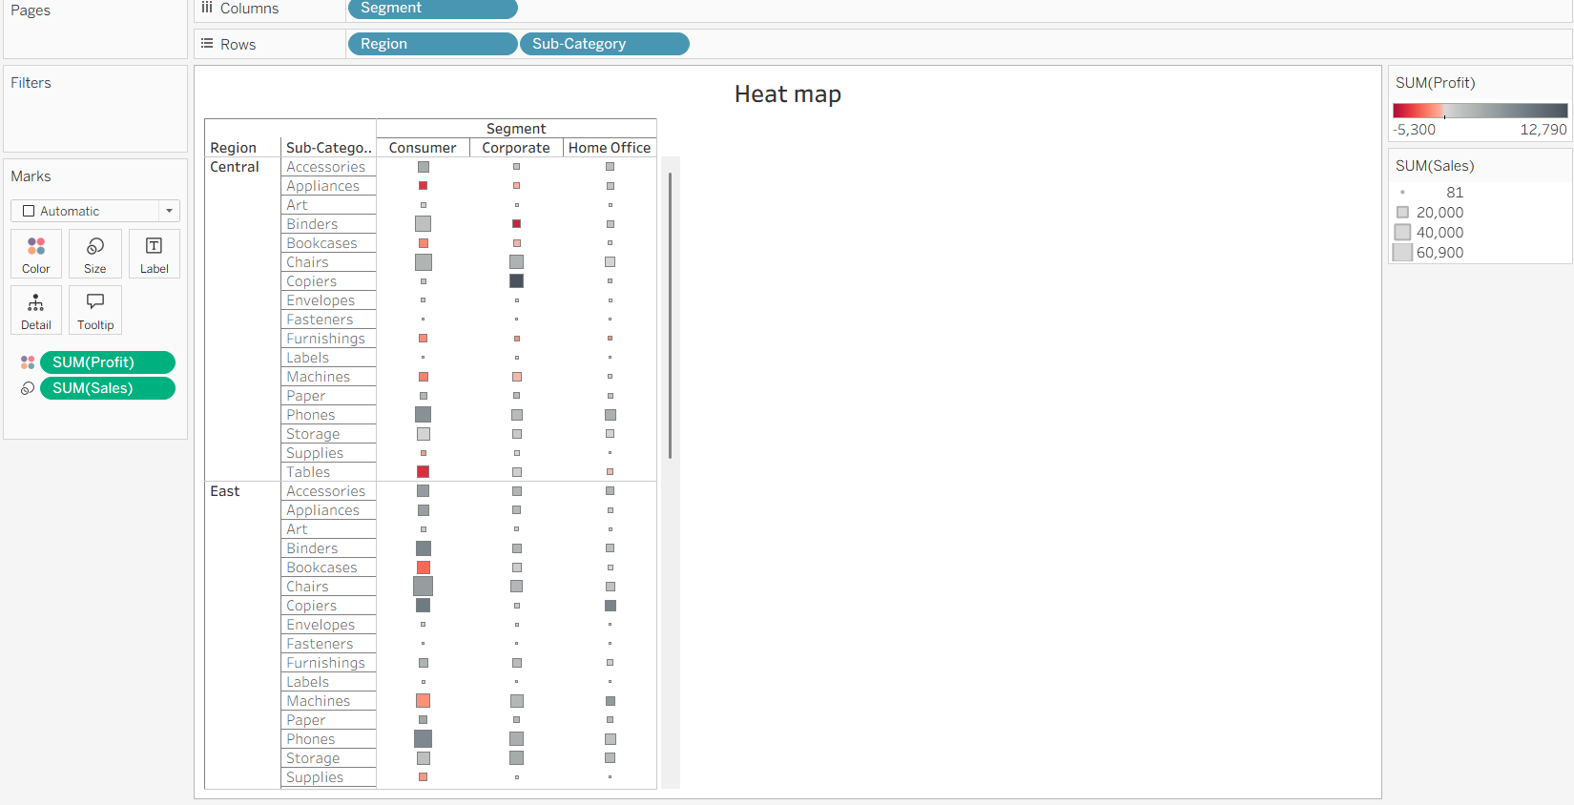

Histogram:
- We have to Drag Quantity into the columns.
- Then Click on Show me (Right side top corner).
- Select Histogram.
- Change the aggregation to CNT(Quantity).
- X-Axis Should be Quantity Bins.
- Y-Axis Should be Count of Orders.
- Drag Segment to colour in the Marks card.
- Hold Ctrl and Drag CNT(Quantity) from rows to Label on Marks card.
- Right Click on CNT(Quantity) on Marks Card.
- Click on Quick Table Calculation.
- Select on Percent of Total.

OUTPUT:
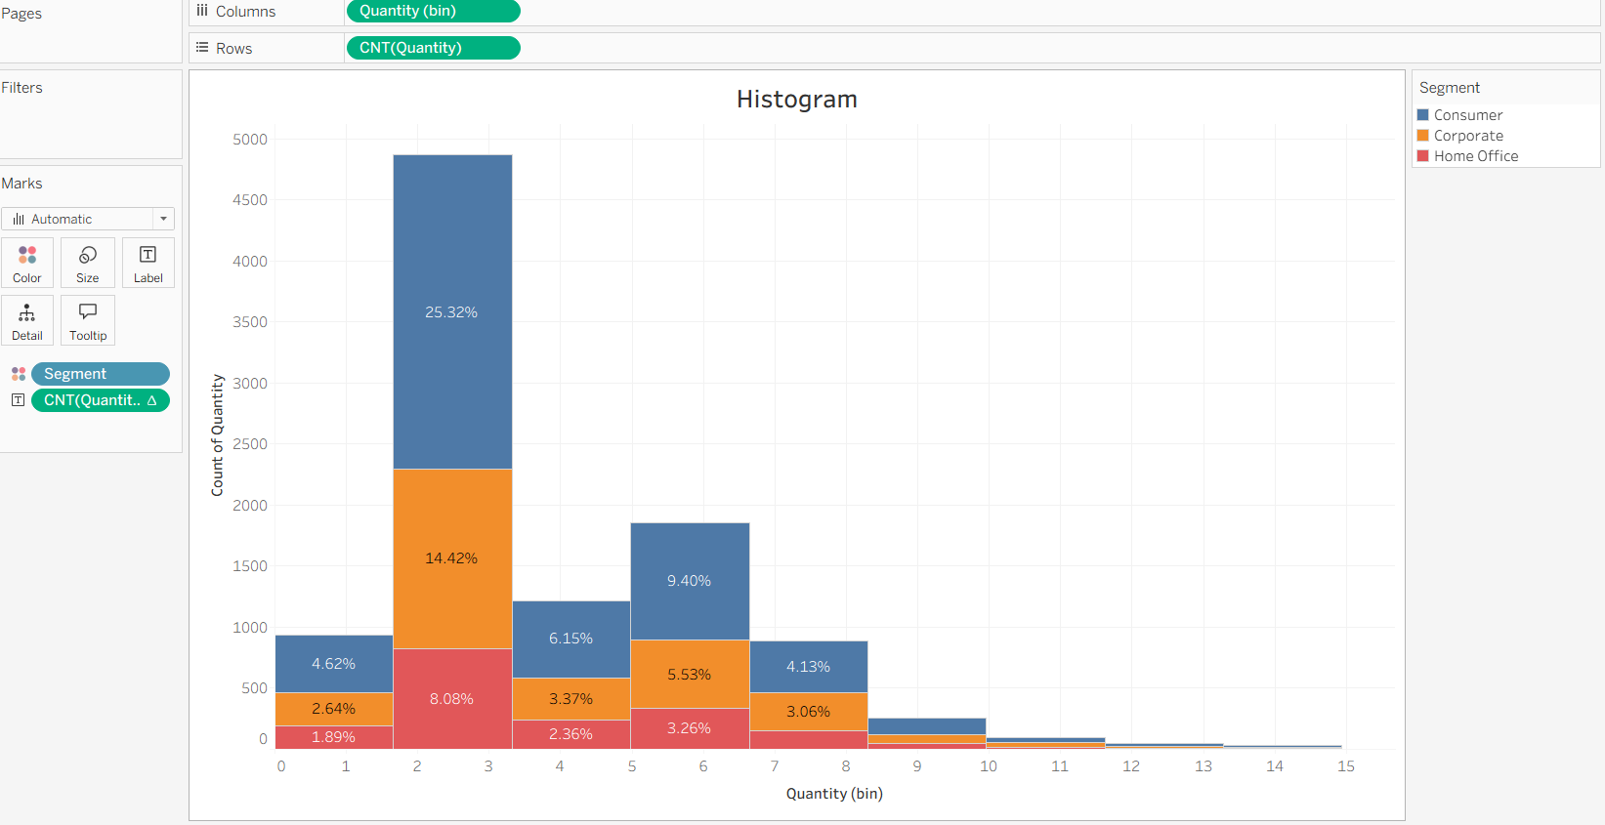

Line Chart:
- We have to Drag Ship mode into the columns.
- Drag Sales into the Rows.
- Drag Profit to rows in the right side of the Sales.
- Then it will shows two separate axis.
- Click on hold sum(Profit), then move it to the Sales axis.
- Then Click on Year(Ship Date).
- Select Month.
- We have to Observe trend.
- Then Click on Analytics Pane.
- Drag Forecast and drop it on the chart.

OUTPUT:
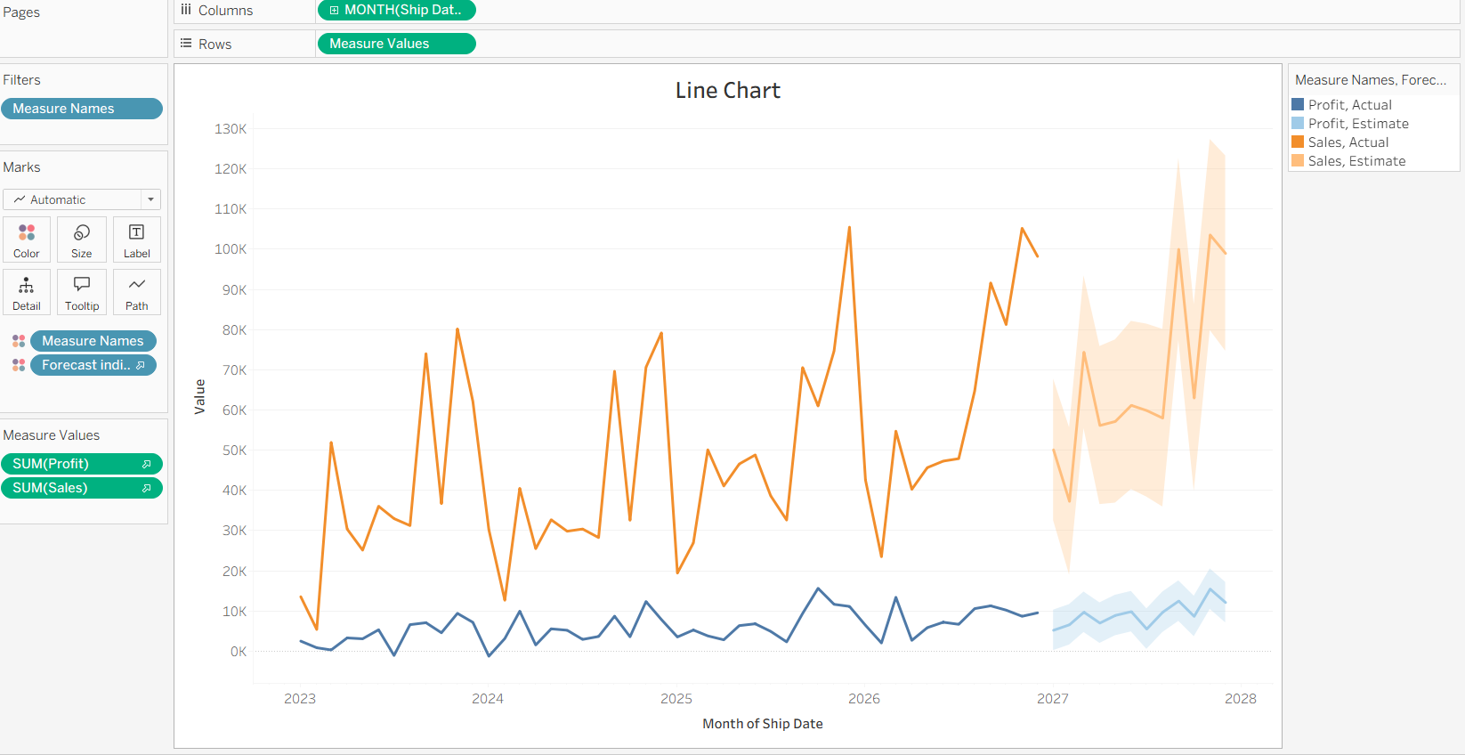

Bubble Chart:
- We have to Drag Category into the columns.
- We have to Drag Sales into the rows.
- Then it will creates like Bar Chart.
- Click on Show me(Right side top corner).
- Select Bubble Chart.
- Drag Region and drop it on Details in the Marks card.
- Again Drag Profit and drop it on colour.
- Again Drag Region and drop it on the Label.

OUTPUT:

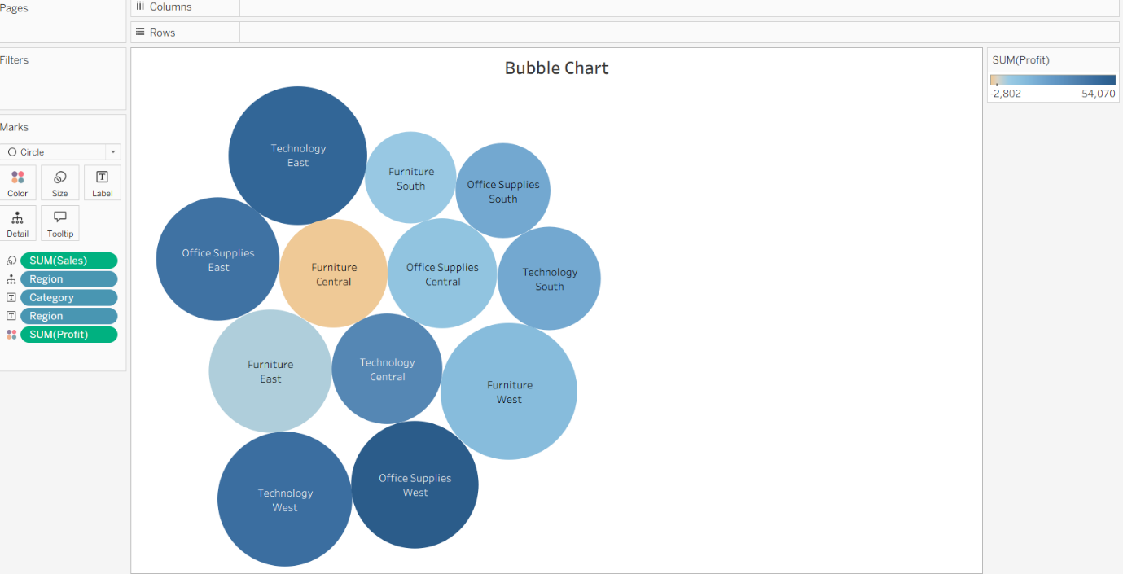

Pie Chart:
- We have to Drag Profit into the columns.
- We have Drag Category into the Rows.
- Then it will create like a Bar chart.
- Click on Show me (Right side top corner).
- Select Pie Chart.
- Click Fit menu in the toolbar.
- Select Entire View.
- Click on Size in the Marks Card. Move right then it will become larger.
- Drag Category and drop it on the Label in the Marks Card.

OUTPUT:
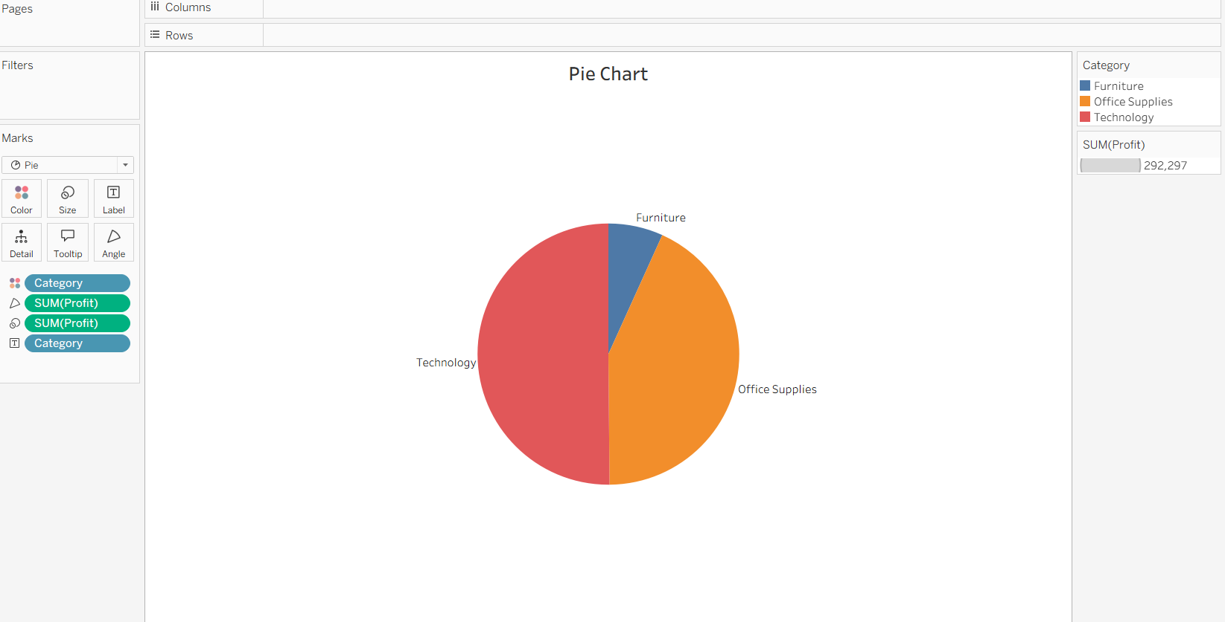

Scatter Plot:
- We have to Drag Sales into the columns.
- We have to Drag Profit into the Rows.
- Drag Category and drop it on the colour in the Marks Cards.
- Drag Region and drop it on the Detail in the Marks Cards.
- Then Click on the Analytics pane.
- Drag the Trend Line and drop it on the Chart.

OUTPUT:
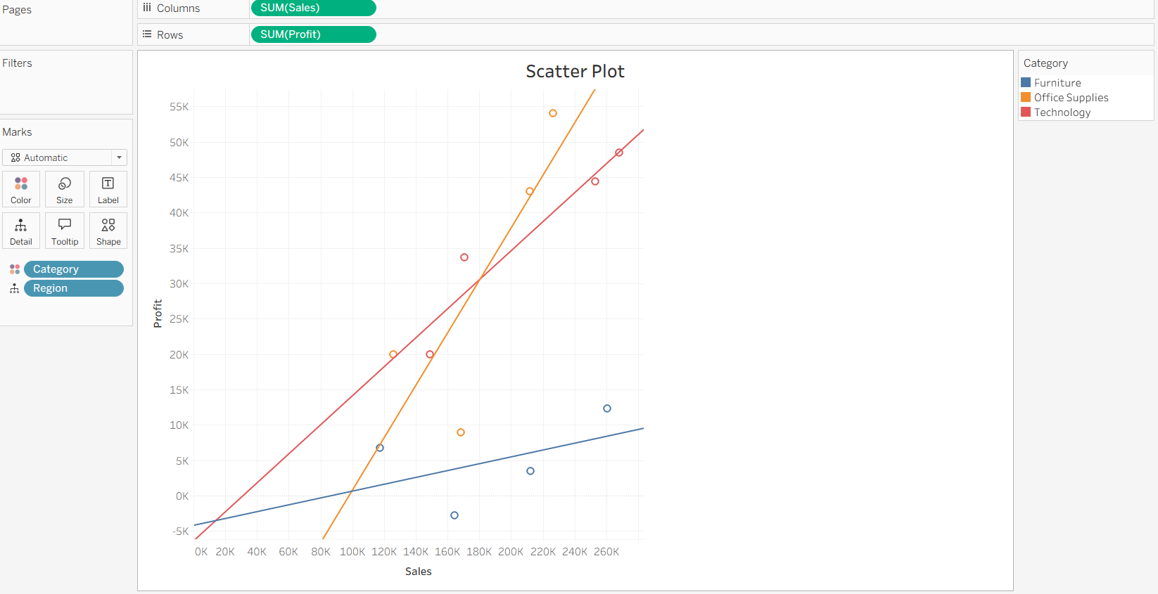

Text Table with Percentages:
- We have to Drag Order Date into the columns.
- We have to Drag Sub Category into the rows.
- Drag Sales and drop it on left side of the Sub category.
- Then right click on Sum (Sales)on Marks card.
- Set Calculation Type Percent of total.
- Set compute using pane (Down).
- Then Click Ok.

OUTPUT:
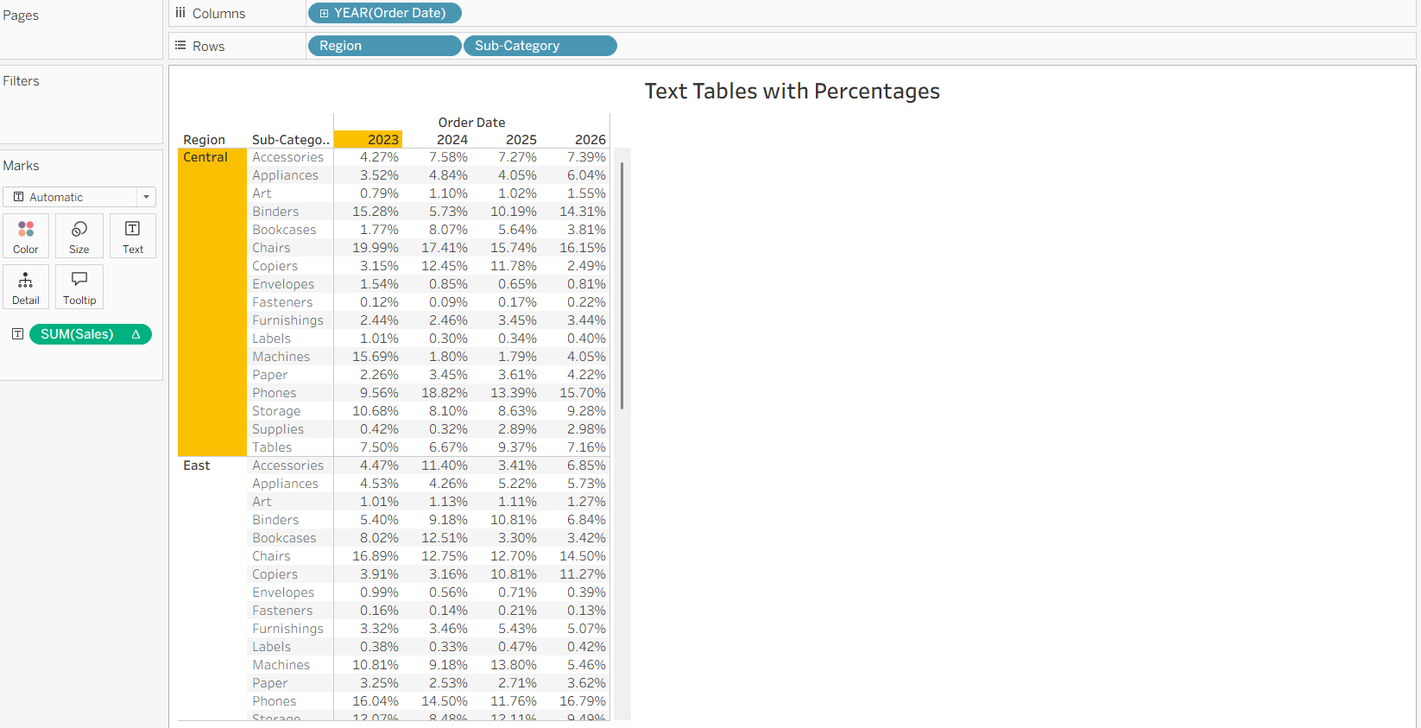

Tree Map:
- We have to Drag Sub Category into the columns.
- We have to Drag Sales into the Rows.
- Click on Show me (Right side top corner).
- Select Tree Map.
- Drag Ship Mode and drop it on colour in the Marks card.
- Click undo to remove Ship Mode.
- Drag Profit and drop it on the colour.

OUTPUT:
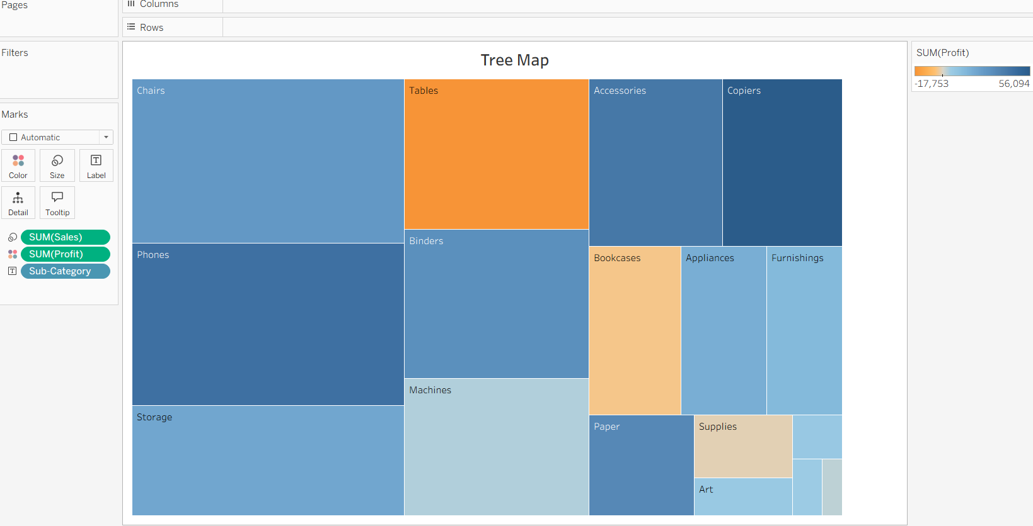

Donut Chart:
- Go to the Analysis menu.
- Select the Create Calculate Field.
- Type the Name field as Zero.
- In the formula, we can type 0(Zero).
- We have to Drag Zero into the Rows.
- In the Marks Card, we have to click automatic.
- Then Select Pie.
- Again, Drag Zero into the Rows.
- Place it on the right side of the first Sum (Zero).
- Then right click on the Second Sum (Zero).
- Select the Dual Axis.
- In the Marks Card, we have to click second Sum (Zero).
- Then Click Size and reduce the size slightly.
- Click the colour.
- Select White Colour.
- Then Click the first Sum (Zero) marks card.
- We have Drag Region into the colour.
- Again, Drag Region to Label in the marks card.
- Drag Sales into the Label.
- Drag Sales into the Angle.
- Then Click the Second Sum (Zero) in marks card.
- Drag Sales to Label.
- Click Label Text.
- Then Click the three dots (…) next to Text to open the text editing box.
- Then Click Ok.

OUTPUT:
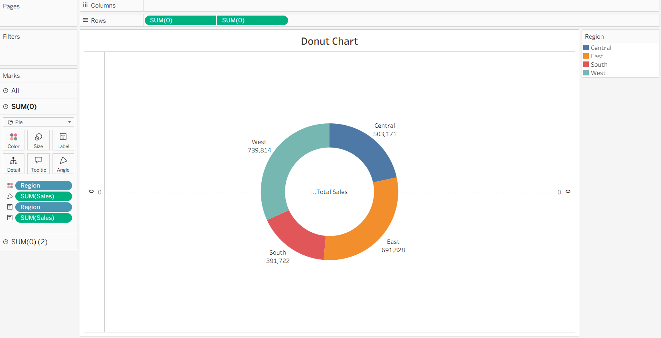

Map Chart:
- We have to Drag Country/Region into the Detail.
- Drag the State/Province into the label on the marks card.
- In the Marks card we have to Click on the automatic and select the Map option.
- Then Drag Sales into the colours on the marks card.

OUTPUT:
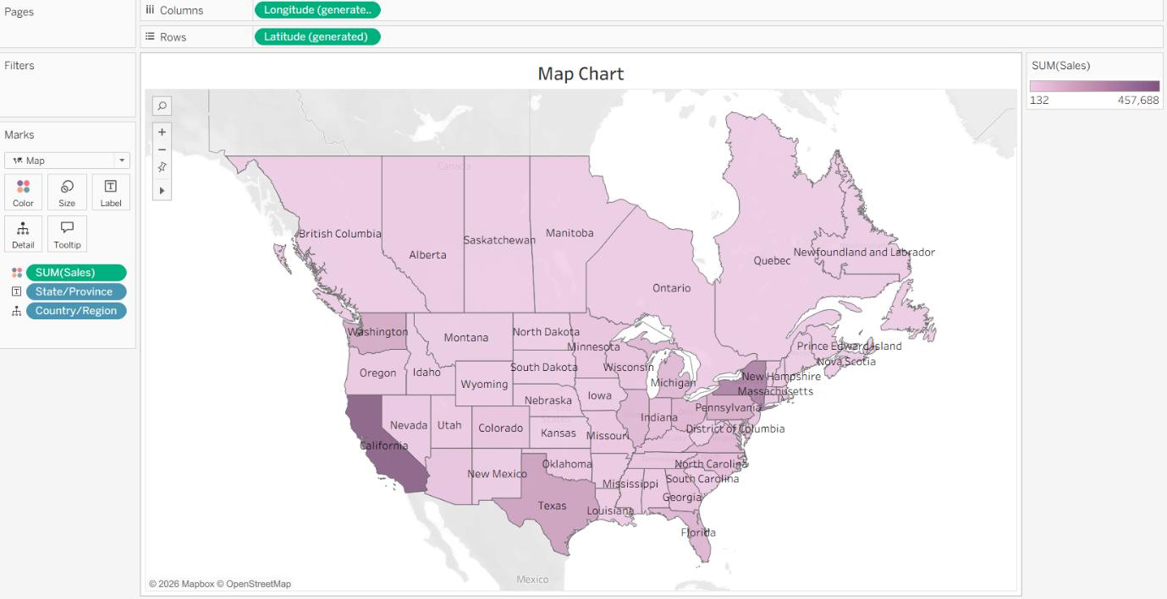

DASHBOARDS:

Dashboard-01:
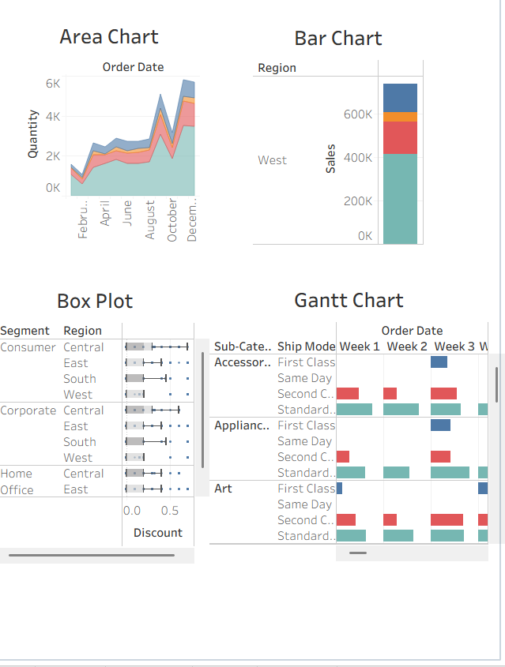

Dashboard-02:
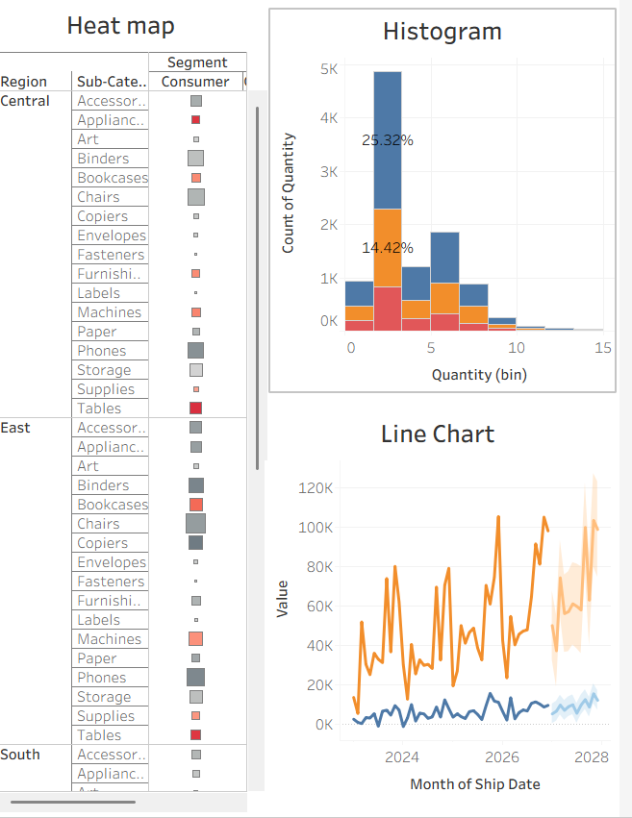

Dashboard-03:
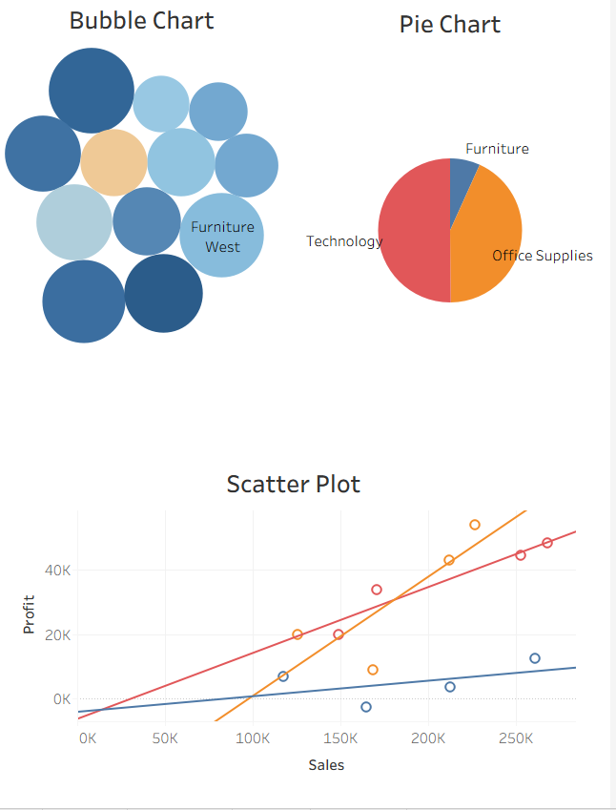

Dashboard-04:
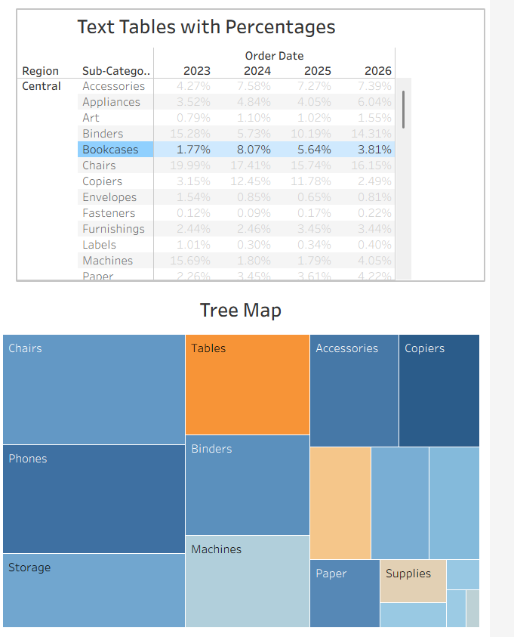

Dashboard-05:
